**PROJECT REPORT**

**MAJOR PROJECT (1 AND 2)**

**RINEX – 7 NOVEMBER**

**MACHINE LEARNING**

**NAME = ANUVRAT VERMA**

**GIT HUB = https://github.com/Anuvrat-Verma**

**COLLEGE NAME = VELLORE INSTITUTE OF TECHNOLOGY BHOPAL**

**COLLEGE ROLL NUMBER = 21BCE10273**

**BRANCH = COMPUTER SCIENCE**

**DATE = 1/02/2023**

**EMAIL =** [**anuvratverma@gmail.com**](mailto:anuvratverma@gmail.com)

**GRADUATION YEAR = 2025**

**CONTACT NUMBER = 8849329261**

**1) Choose any dataset of your choice and apply a suitable CLASSIFIER/REGRESSOR .**

DATASET = STAR DATASET (KAGGLE)

DATASET LINK = https://www.kaggle.com/datasets/deepu1109/star-dataset

**I HAVE APPLIED LINEAR REGRESSION TO FIND THE STAR TYPE AND SPECTRAL CLASS USING ALL OTHER COLUMNS AS INPUTS**

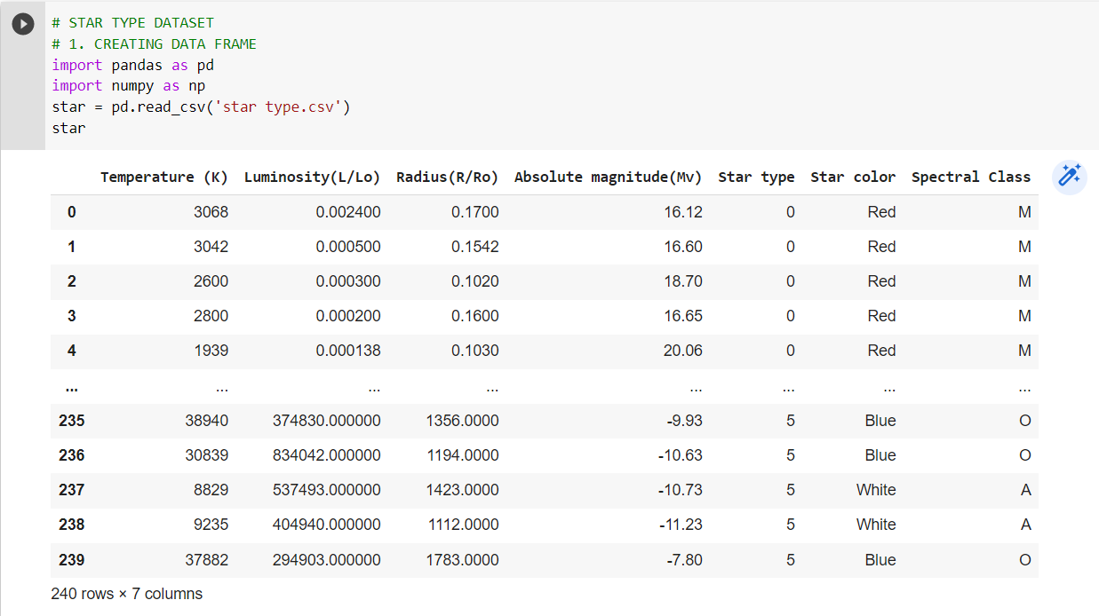

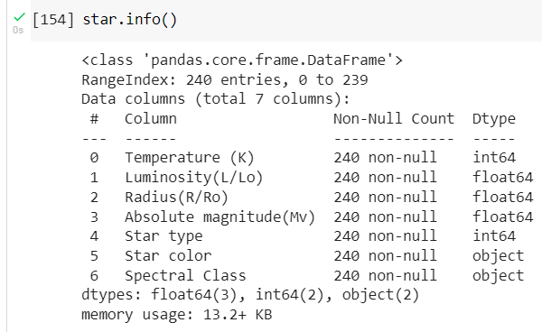

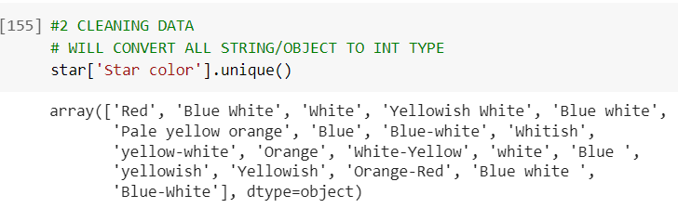

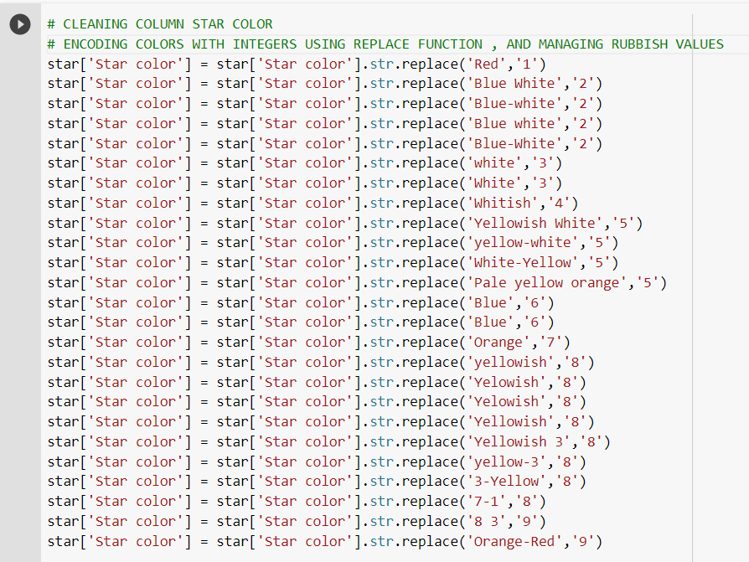

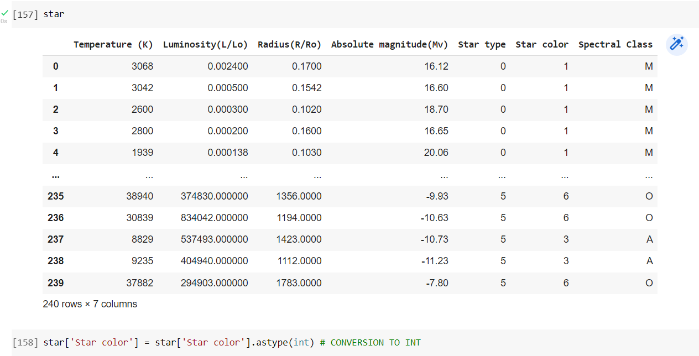

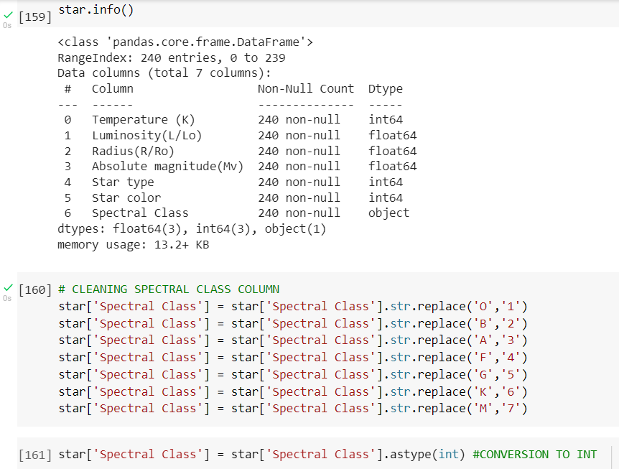

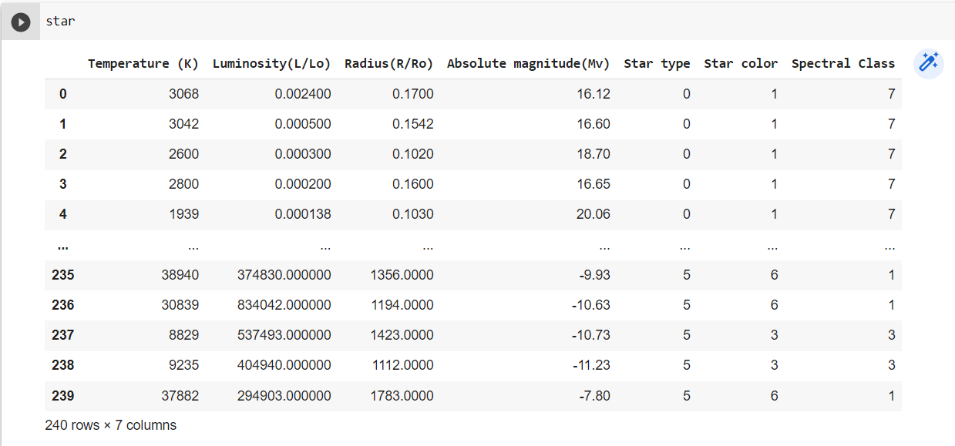

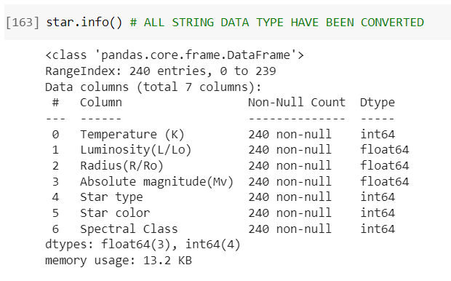

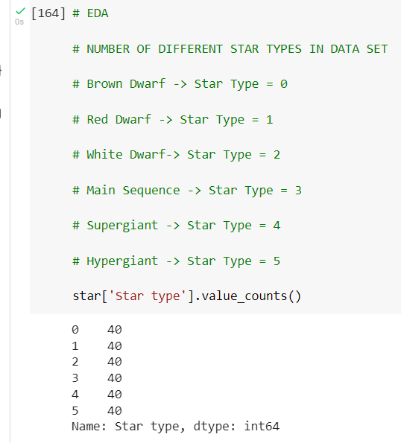

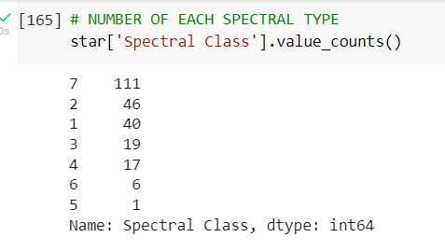

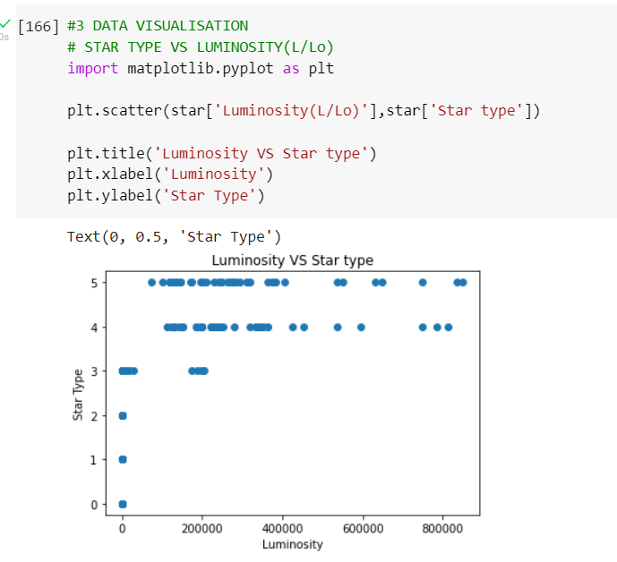

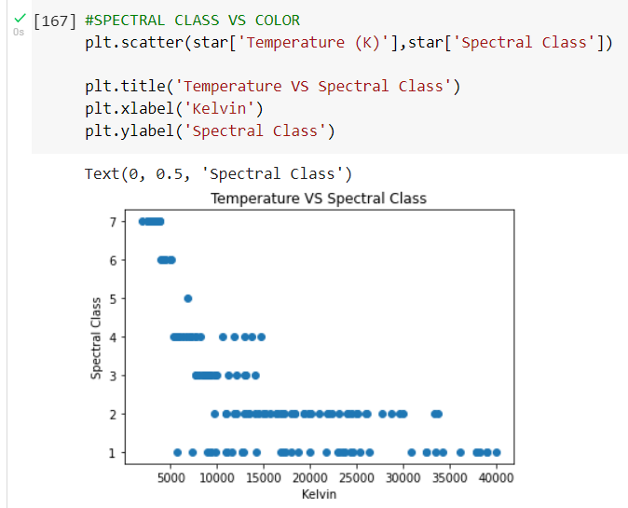

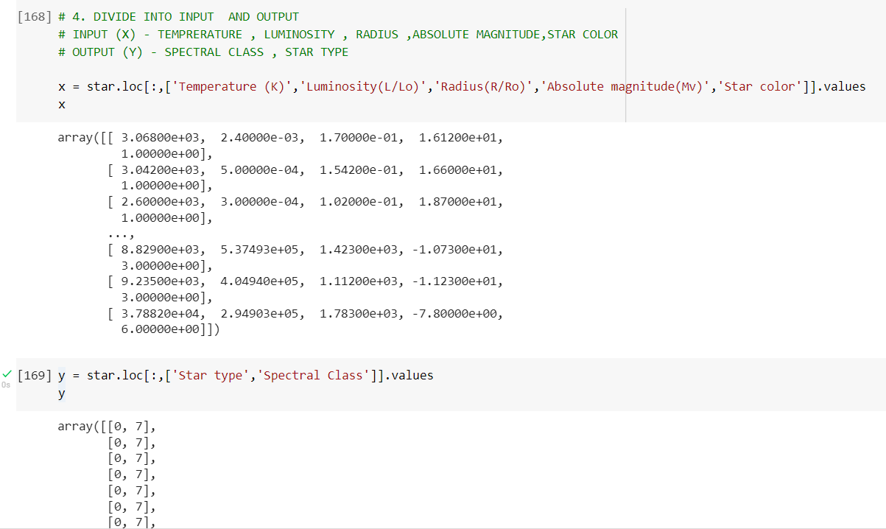

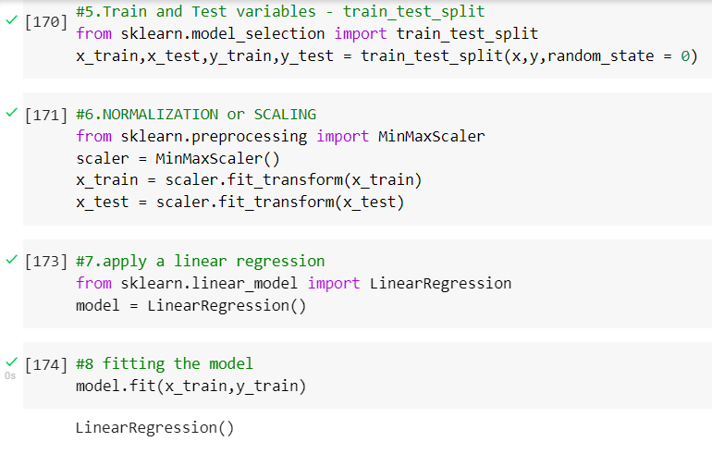

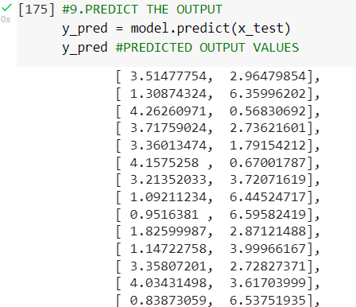

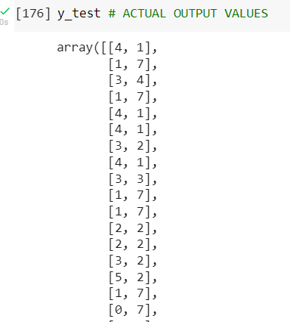

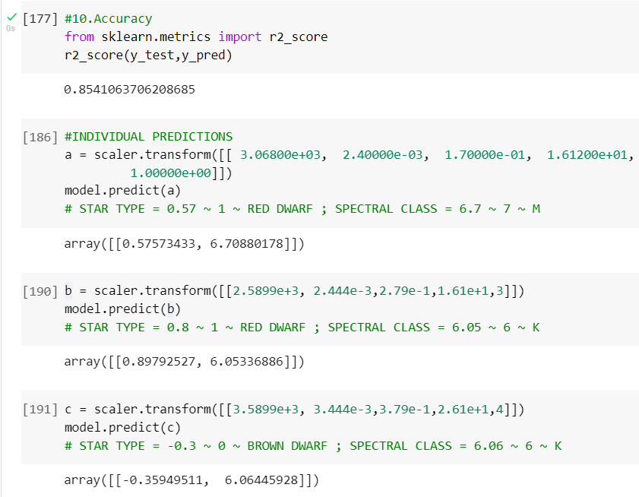

**2) Choose any dataset of your choice and Perform Exploratory Data Analysis for Atleast 15 different facts/Conclusions.**

DATASET = RESERVATION AND CANCELLATION PREDICTION (HOTEL)

DATASET LINK = <https://www.kaggle.com/datasets/gauravduttakiit/reservation-cancellation-prediction?select=train__dataset.csv>

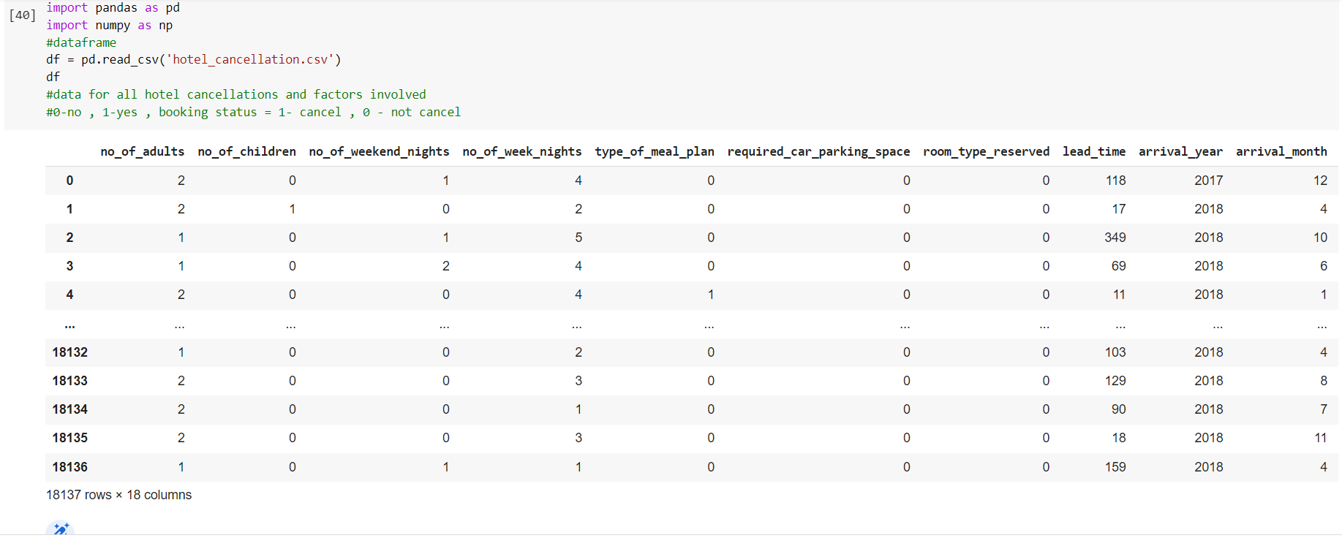

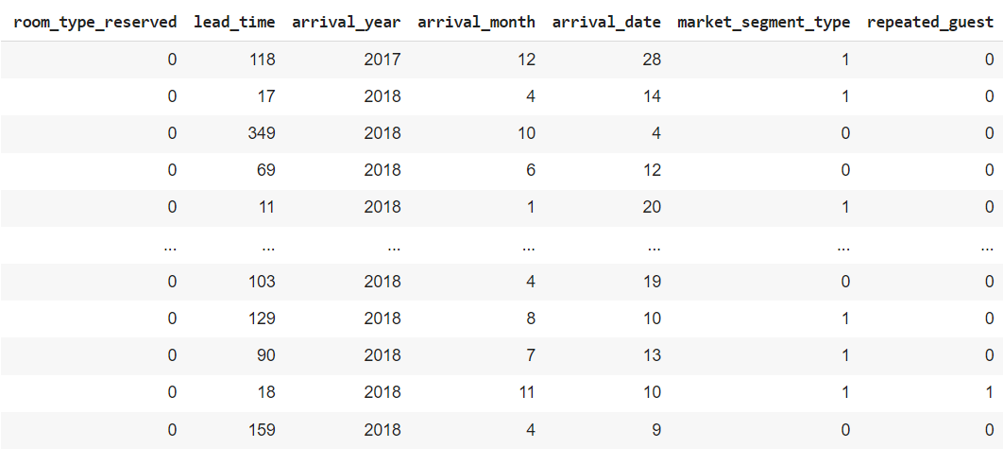

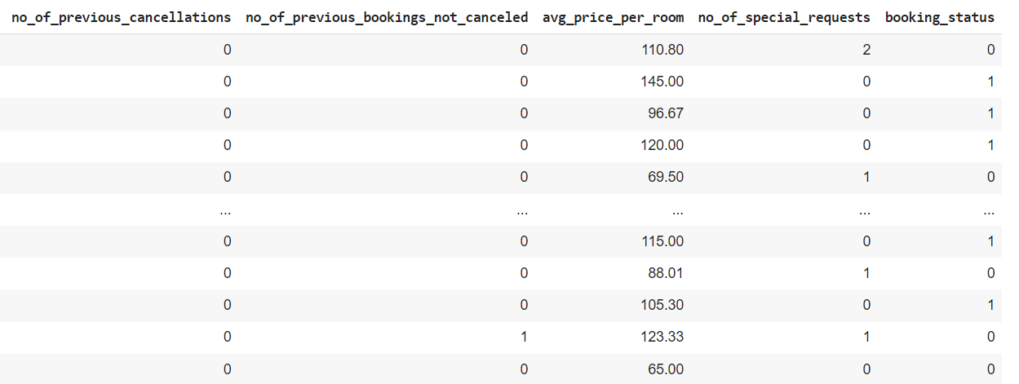

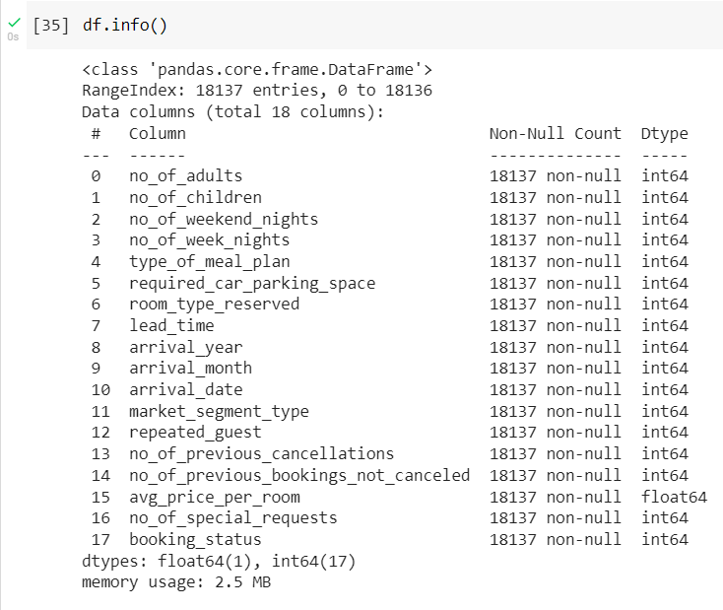

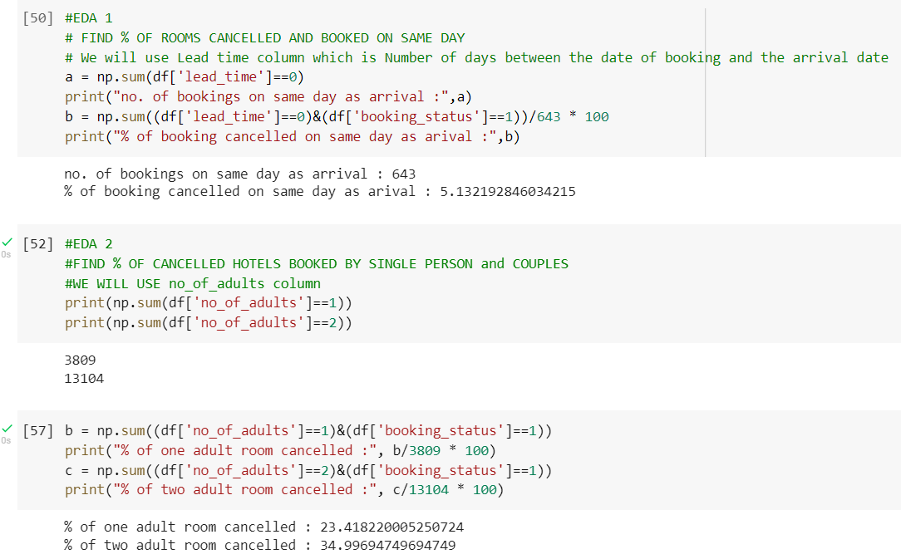

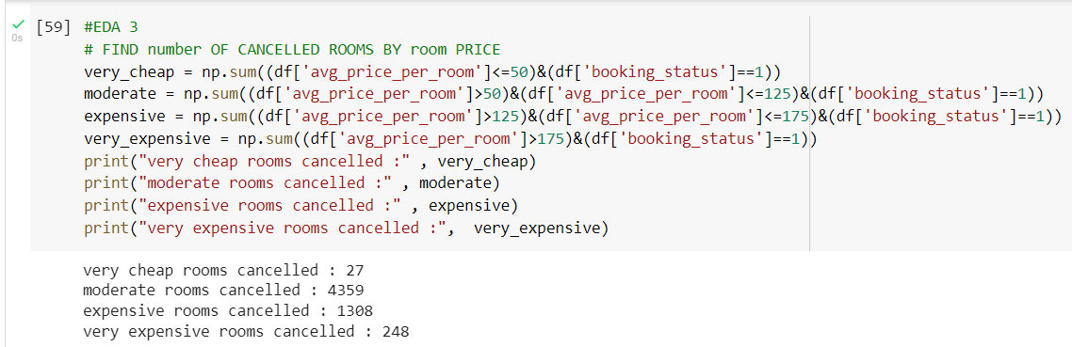

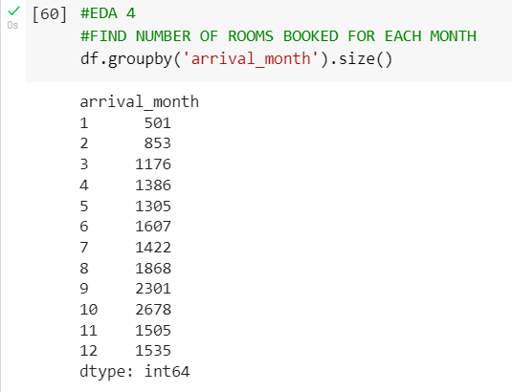

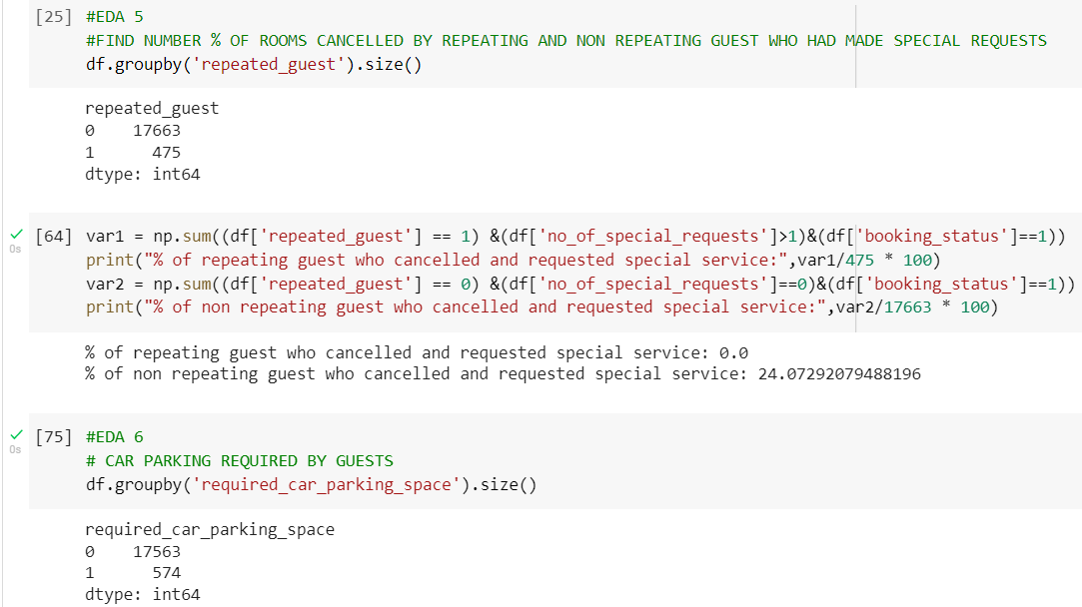

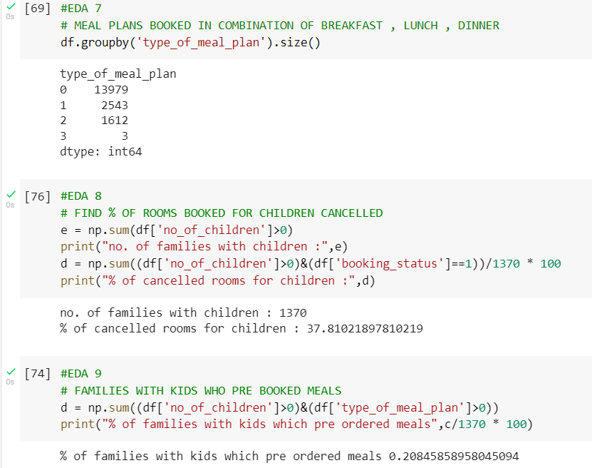

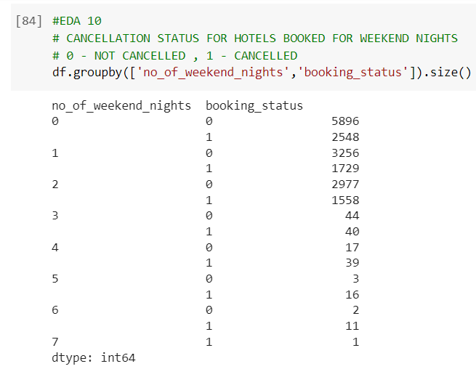

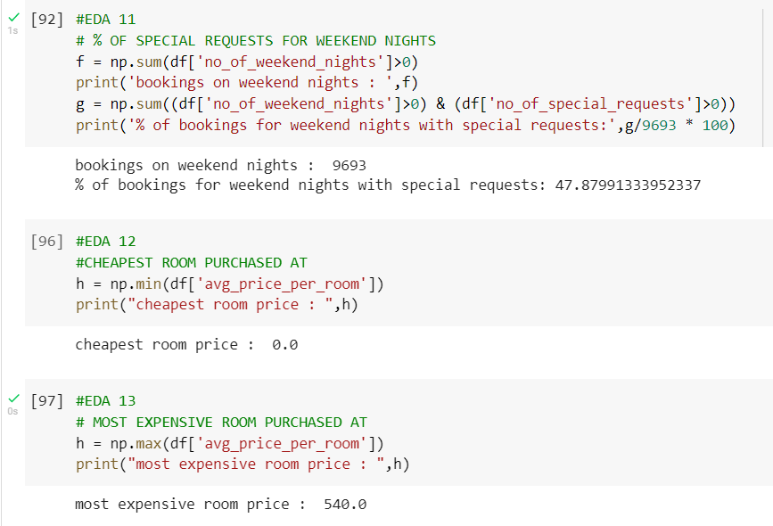

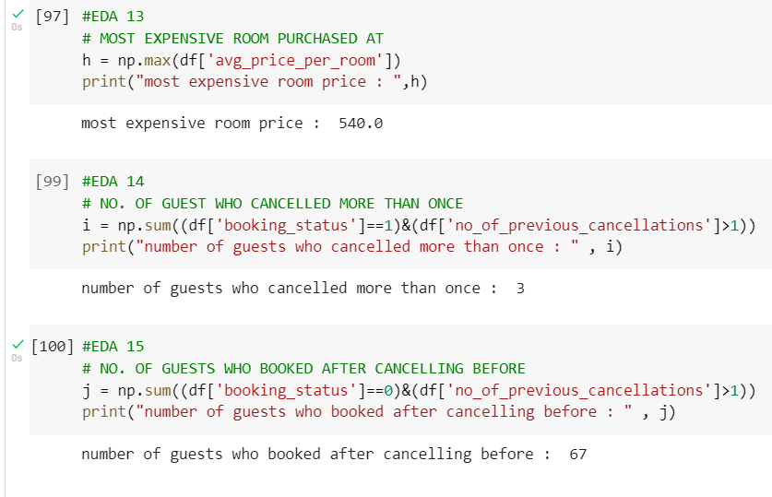

**END OF REPORT**